**Sprint 4 – My Profile Page**

|  |  |
| --- | --- |
| **As a** | Registered user of <https://FinTrust.com> |
| **I want** | to be able View and Edit My Profile Page |
| **So that** | I can verify my details to check if they are correct and update whenever necessary. |
| **Acceptance Criteria** | 1. As a registered user of <https://FinTrust.com>, System shall allow users to access My Profile Page (refer Appendix 2: ‘My Profile’ Page Wireframe and Appendix 3: ‘My Profile’ Page Data Table) 2. System displays My Profile Icon/Button on the top left corner of the Account Summary Page. 3. On click of ‘My Profile’ Page Icon/button, system navigates the user to the My Profile Page. 4. System fetches the Account Holder data from the database and displays it onto the same page. 5. System allows user to view their profile information. 6. System allows user to only edit their Email Address all other details are not editable. 7. Once the user updates their email address, they are not allowed to edit it or update it again for next 14 days. 8. If the user tries to edit or update for more than once in the in these 14 days, the system will throw an inline error message (refer Appendix 4: error message Wireframe) |

**Appendix 1:** ‘My Profile’ Page Process Flow

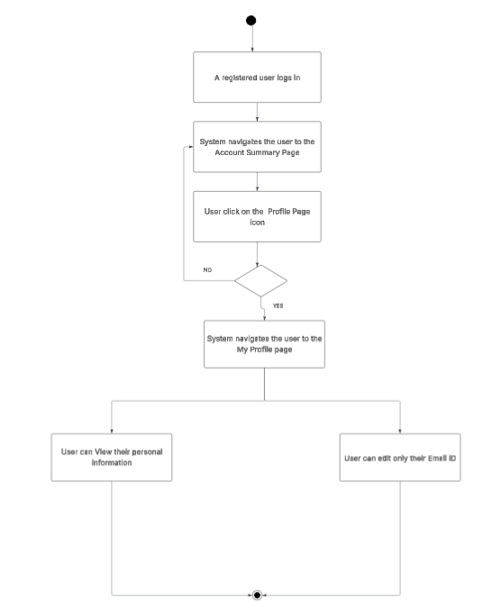

**Appendix 2:** Display ‘My Profile’ Page wireframe

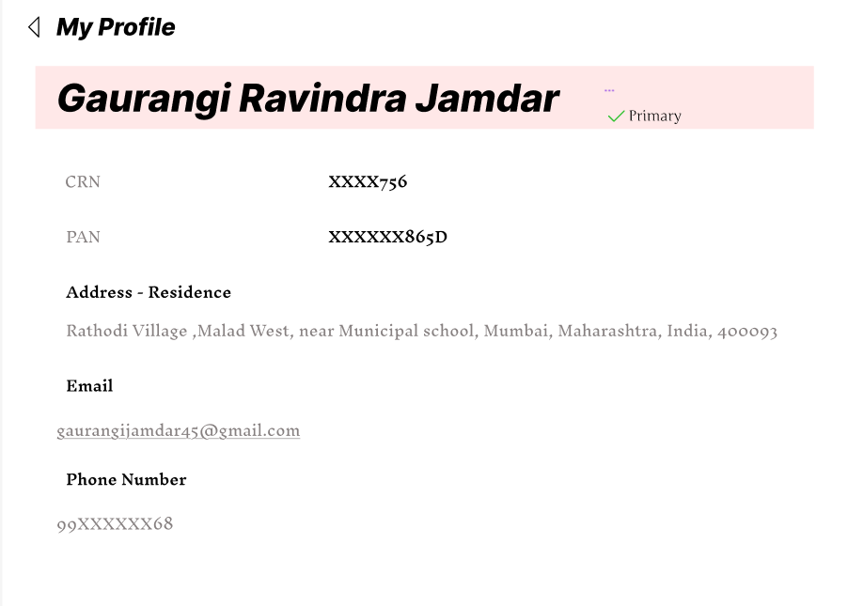

**Appendix 3:** Data Table for ‘My Profile’ Page

|  |  |  |  |  |  |
| --- | --- | --- | --- | --- | --- |
| **ID** | **Field Name** | **Field Type** | **Content** | **Required Field?** | **Notes** |
| 1 | My Profile | Text | N/A | N/A | Page Title |
| 2 | Account Holder Name | Text | N/A | N/A | Display the account holder name in Bold |
| 3 | CRN | Masked text | N/A | N/A | Keep the first 4 digit masked. |
| 4 | PAN | Masked text | N/A | N/A | Display only the last four letters |
| 5 | Primary status | Text | N/A | N/A | Indicates that the profile is primary. |
| 6 | Address | Alphanumeric | N/A | N/A | Display the full address of the account holder. |
| 7 | Email ID | Alphanumeric | N/A | N/A | - |
| 8 | Phone no | Numeric | N/A | N/A | The phone number should be a 10 digit numeric value.  Display only first & last two digits. |

**Appendix 5:** Error message Wireframe

